<https://www.youtube.com/watch?v=5aYvPsP2zvw>

<https://www.youtube.com/watch?v=CXFwenaIEi8>

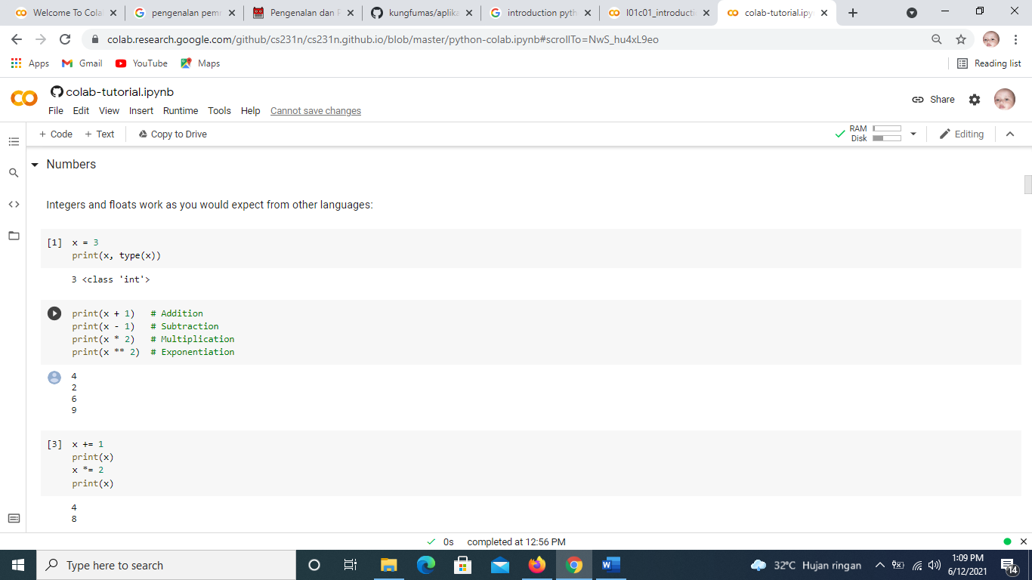

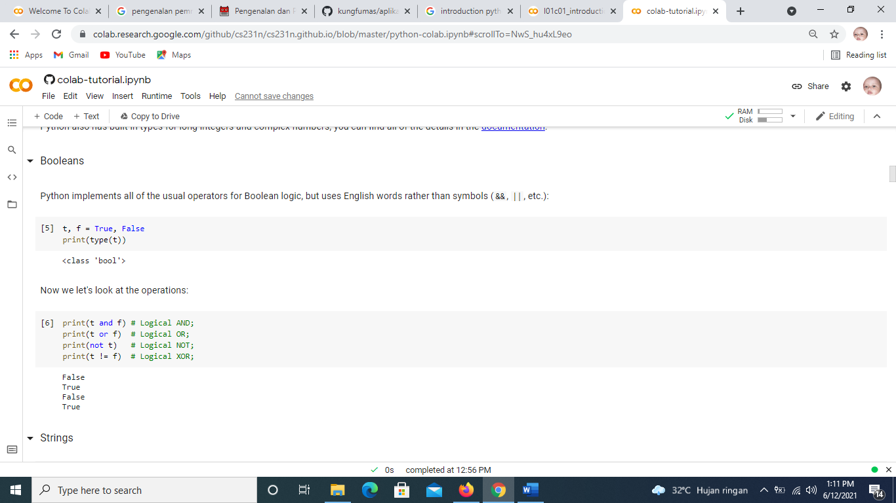

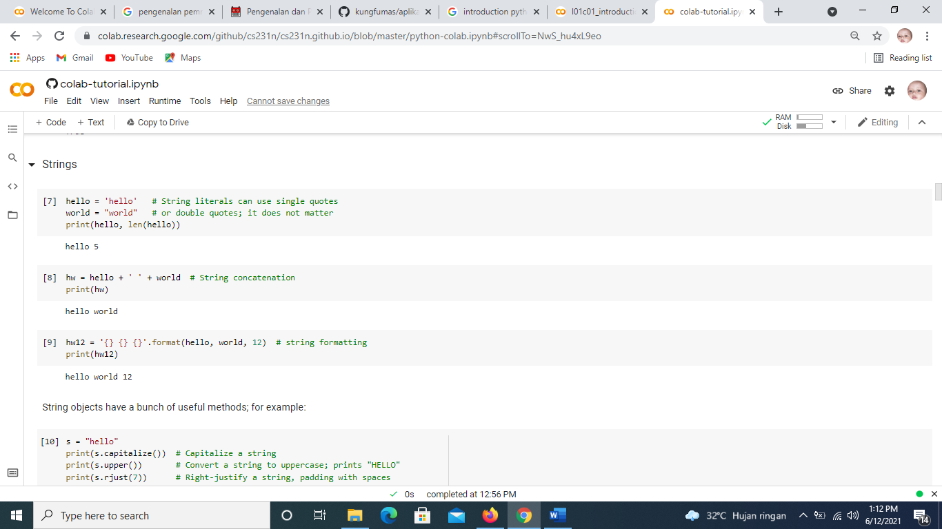

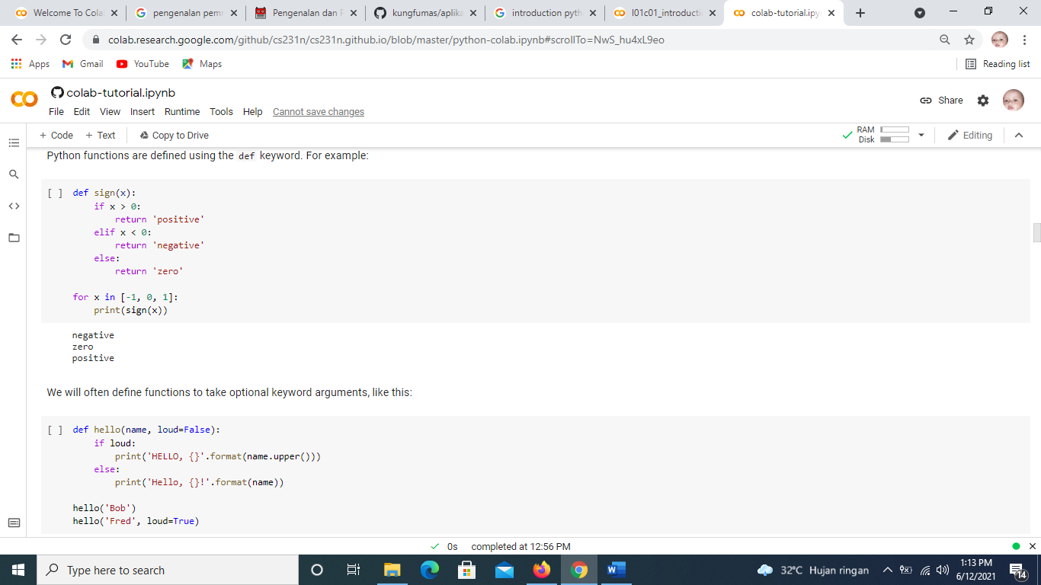

https://www.kaggle.com/mauriciofigueiredo/fruit-classification-with-a-simple-cnn